ECON 300 – Labour Economics
Final Exam
EXAMINER: Muhebullah Karimzada
April 21, 2026

Instructions:
1. You have 150 minutes to work on the exam.
2. This exam is individual and closed-book.
3. For the multiple-choice questions, choose the option that best answers/completes the question.
4. This Examination paper includes 21 pages (includes the cover page). You are responsible for ensuring that your copy of the paper is complete. Bring any discrepancy to the attentions of your invigilator.

PLEASE: PUT YOUR NAME AND STUDENT ID ON EVERY SHEET!!

Multiple Choice Answers:

1. _________ 17. _________ 33. _________ 49. _________ 65. _________

2. _________ 18. _________ 34. _________ 50. _________

3. _________ 19. _________ 35. _________ 51. _________

4. _________ 20. _________ 36. _________ 52. _________

5. _________ 21. _________ 37. _________ 53. _________

6. _________ 22. _________ 38. _________ 54. _________

7. _________ 23. _________ 39. _________ 55. _________

8. _________ 24. _________ 40. _________ 56. _________

9. _________ 25. _________ 41. _________ 57. _________

10. _________ 26. _________ 42. _________ 58. _________

11. _________ 27. _________ 43. _________ 59. _________

12. _________ 28. _________ 44. _________ 60. _________

13. _________ 29. _________ 45. _________ 61. _________

14. _________ 30. _________ 46. _________ 62. _________.

15. _________ 31. _________ 47. _________ 63. _________

16. _________ 32. _________ 48. _________ 64. _________
MULTIPLE CHOICE. Choose the one alternative that best completes the statement or answers the question.

- Which of the following statements concerning the elasticity of labour supply is true?
              - The total wage elasticity of supply tends to be positive and of low magnitude.
              - The income elasticity of supply tends to be positive and of low magnitude
              - The compensated elasticity of supply is close to zero
              - Overall workers tend to be highly responsive to wage changes
              - None of these above statements are true

- Suppose a worker is observed to be working but is forced to work fewer hours than she really wants to work. Which of the following statements is true?
              - The indifference curve that she is on is tangent to the budget line.
              - She is on an indifference curve which is lower than the one which is tangent to her budget line.
              - She is on an indifference curve which is higher than the one which is tangent to her budget line.
              - She is on an indifference curve which is lower than the one which passes through the point on the budget line corresponding to zero hours of work.
              - She is not on an indifference curve.

- The reservation wage is defined as:
              - the wage of the reservation clerk in the tourism industry.
              - the maximum wage that an employer is willing to pay a worker for a given job.
              - the minimum wage that an employee is willing to accept for a given job.
              - the equilibrium wage.
              - the wage rate at which zero hours of labour is supplied by the workers.

- Which one of the following regarding to an individual's budget constraint is correct?
              - The slope of the budget constraint is determined by the market wage rate.
              - The level of non-labour income determines the intercept of the budget constraint.
              - The slope of the budget constraint is determined by the reservation wage rate
              - The slope of the budget constraint is equal to the marginal rate of substitution between income and leisure
              - The slope of the budget constraint is higher for a full-time worker than for a part-time worker.

- In the neo-classical model of labour supply, which of the following is always true?
              - If leisure is a normal good, a wage increase causes an increase in hours worked.
              - If leisure is a normal good, a wage increase causes a decrease in hours worked.
              - The income effect and the substitution effect work in the same direction.
              - The substitution effect causes the worker to work more hours if wages increase.
              - None of these options

- All of the following describe a demogrant except:
              - an income grant to a specific demographic group
              - the simplest income maintenance program
              - A grant whose amount varies with the worker's wage
              - a lump-sum transfer
              - That it shifts the potential income constraint vertically upward

- Which of the following situations is depicted in this figure? G refers to a government benefit payment

.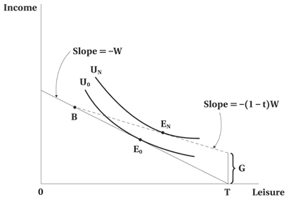
              - The absence of any income maintenance scheme
              - The Canadian Employment Insurance scheme
              - The wage subsidy scheme
              - The conventional welfare program
              - The negative income tax scheme

- The reason for which worker's disability insurance can potentially have adverse effects on work incentives is that:
              - the income that it provides enables one to reach a certain income level without any work obligation.
              - the opportunity cost of leisure increases.
              - the recipient is allowed to work as many hours as he/she can without losing any of the benefits.
              - the taxes that finance the benefits can have negative effects on labour demand.
              - All of the answer choices are correct.

- The Canadian Employment Insurance Program is best known for its generosity towards:
              - Long-term unemployed workers
              - Older unemployed workers
              - High-wage unemployed workers
              - Seasonally unemployed workers
              - No particular group of unemployed workers

- Which of the following statements concerning subsidies for child care expenses is true?
              - They change the slope of the budget line.
              - They reduce the fixed costs of working.
              - They discourage labour force participation.
              - They tend to increase the reservation wage of working.
              - They cause a strong substitution effect toward more working activity.

- Assume that at the wage rate of $10 per hour, a firm is hiring 100 hours of labour per week. If the wage elasticity of demand is -1.2, how many hours of labour will the firm shed if the wage increases by $2 per hour?
              - 5 hours per week
              - 12 hours per week
              - 20 hours per week
              - 24 hours per week
              - 36 hours per week

- If the employer is a monopolist in the output market:
              - There is monopsony in the input market.
              - The demand for labour is less elastic than it would be if the firm operated in a competitive output market.
              - The demand for labour is less elastic than it would be if the firm operated in a competitive input market.
              - The firm's demand curve for labour is identical to the case where the firm is a competitor in the output market.
              - None of the above choices are correct.

- Suppose that the wage elasticity of labour demand is -0.55. Which of the following statements is true?
              - A $ 1 increase in wages corresponds to a 0.55 unit decrease in quantity demanded of labour
              - A $ 0.55 increase in wages corresponds to a 1 % decrease in quantity demanded of labour
              - A 0.55 % increase in wages corresponds to a 1 % decrease in quantity demanded of labour
              - A $ 1 increase in wages corresponds to a 0.55 % decrease in quantity demanded of labour
              - A 1 % increase in wages corresponds to a 0.55 % decrease in quantity demanded of labour

- For labour demand choices, the long run is defined as:
              - the time period over which all costs are fixed.
              - the period of time over which all inputs can vary.
              - the period of time over which fixed factors cannot vary.
              - the period of time over which variable factors can vary.
              - the period of time over which variable factors cannot vary.

- In the short run, the demand for labour for a competitive firm is:
              - the marginal product of labour curve.
              - the same as the total demand curve for labour.
              - the downward sloping portion of the value of the marginal product curve.
              - perfectly elastic at the market wage.
              - perfectly inelastic at the market wage.

- With respect to labour demand choice in the long run, which of the following statements is false? MPP_{L} = marginal physical product of labour, MPP_{K} = marginal physical product of capital, w = wage, and r = rate of return on capital
              - The rate at which capital can be substituted for labour in the technology of production is equal to the rate at which capital and labour can be exchanged in the market
              - MPP_{L}/MPP_{K} = w/r.
              - MPP_{L} * r = MPP_{K}* w
              - The profit made per worker is maximized
              - The marginal rate of technical substitution is equal to the ratio of factor prices

- The scale effect of a wage change implies that:
              - Firms substitute toward the input that has become relatively cheaper.
              - The wage elasticity of demand is inelastic
              - The demand for labour may be upward sloping if labour is an inferior input.
              - The firm reduces its output in response to the wage increase.
              - In order to increase output, a firm will use more labour even if the wage increases.

- The slope of an isoquant reflects:
              - the marginal cost of labour.
              - the wage elasticity of the demand for labour.
              - the marginal rate of technical substitution between inputs.
              - the marginal productivity of capital.
              - the marginal productivity of labour.

- Which of the following is correct regarding the elasticity of labour demand?
              - If capital and labour are easily substitutable, the derived demand for labour will be inelastic.
              - If the supply of substitute inputs is inelastic, the derived demand for labour will be inelastic.
              - If the product demand is elastic, the derived demand for labour will be inelastic.
              - If the share of the labour costs in total costs is large, the derived demand for labour will be inelastic.
              - None of the choices are correct.

The following diagrams of budget constraints pertain to the next three questions. The vertical axis is Income and the horizontal axis is Leisure.
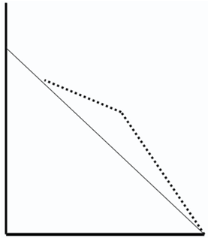 Figure a) 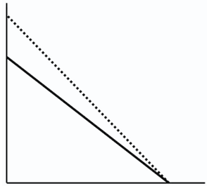Figure b)
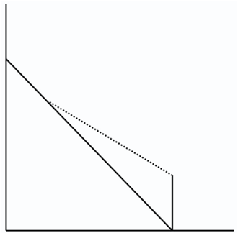Figure c) 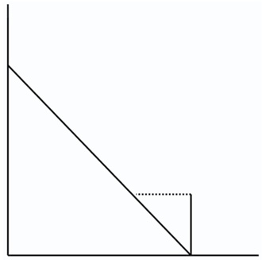 Figure d)

- Which of the diagrams of budget constraints above depicts the Earned Income Tax Credit program?
                - a)
                - b)
                - c)
                - d)

- Which of the diagrams of budget constraints above depicts the Wage Subsidy program?
                - a
                - b
                - c
                - d

- Which of the diagrams of budget constraints above depicts the Negative Income Tax program?
                - a
                - b
                - c
                - d
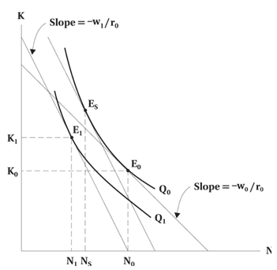
- Assume that the wage increases from W₀ to W₁, but the rate of interest remains at r₀. The substitution effect is given by:
                - N₀ to N_{S}
                - N₀ to N₁
                - N_{S} to N₁
                - K₀ to K₁
                - We cannot tell

- Assume that the wage increases from W₀ to W₁, but the rate of interest remains at r₀. The scale effect is given by:
                - N₀ to N_{S}
                - N₀ to N₁
                - N_{S} to N₁
                - K₀ to K₁
                - We cannot tell

- If workers receive economic rents, then:
              - They are receiving wages which are higher than the competitive level.
              - They are receiving wages which are below the competitive level.
              - If wages were to be increased, the employment level would rise.
              - If wages were to be reduced, the firm would no longer be able to recruit labour.
              - The product market could be perfectly competitive.

- What is the primary difference between a monopsonist and a firm which operates in a perfectly competitive labour market?
              - The monopsonist is likely to be more profitable.
              - In order to recruit another worker, the monopsonist incurs a larger increase in labour costs.
              - In order to recruit another worker, the monopsonist incurs a smaller increase in labour costs.
              - The monopsonist hires such that the marginal revenue product of labour is equal to the marginal labour cost, but the non-monopsonist does not.
              - The labour supply curve is irrelevant for the monopsonist.

- The supply of labour to an industry is generally upward sloping because:
              - Workers are more willing to work when there is the added incentives in the form of higher wages.
              - It is more profitable for firms to hire more workers when labour is cheap.
              - The substitution effect and the scale effect of a wage change work in the same direction.
              - The wage elasticity of labour supply is elastic.
              - There are many workers working for an industry.

- Which of the following statements is true? The burden of a payroll tax is paid:
              - by workers if the supply of labour is perfectly elastic.
              - by workers if the demand for labour is perfectly inelastic.
              - by both workers and firms if the elasticities of demand and supply of labour are between zero and infinity.
              - by firms if they are legally responsible for remitting the tax to the government.
              - by workers if the taxes are withheld from their paychecks government.

- What is the expression for the wage elasticity for a linear demand curve?
              - W / N^{d}
              - Δ W / Δ N^{d}
              - Δ N^{d} / Δ W
              - (Δ N^{d} / N^{d}) / (Δ W / W)
              - (Δ W / W) / (Δ N^{d} / N^{d})

- The curvature of the iso-utility curve illustrates:
              - a diminishing marginal rate of transformation between wages and job safety.
              - a diminishing marginal rate of substitution between wages and job safety.
              - the diminishing marginal rate of technical substitution between wages and job safety.
              - the level of safety that can be exchanged for wages on the labour market.
              - the law of diminishing marginal returns applied to wages.

- Fill in the blanks in the sentence below. The more ________ the individual worker, the more he/she requires a _________ compensating wage differential in return for accepting a riskier work environment.
              - risk-averse; larger
              - risk-loving; larger
              - risk-averse; smaller
              - risk-neutral; smaller
              - risk-neutral; larger

- The slope of the wage-safety locus gives:
              - The change in the wage premium that the labour market yields for differences in the salary of each worker.
              - The change in the wage premium that the labour market yields for differences in the degree of risk of the job.
              - The change in the wage premium that the labour market yields for differences in the utility levels of workers.
              - The change in profitability that is associated with different combinations of wages and job safety.
              - The change in the wage premium that the labour market yields for differences in the preference of the workers.

- Consider an equilibrium between a firm and a worker that consists of a relatively low wage and a relatively high degree of safety. How would one describe the parties?
              - A relatively safe firm and a relatively risk-averse worker
              - A relatively unsafe firm and a relatively risk-averse worker
              - A relatively safe firm and a not so risk-averse worker?
              - A relatively unsafe firm and a not so risk-averse worker?
              - We cannot tell given this information

- According to the signaling theory of education,
              - The level of education or training directly measures the productivity of the worker.
              - The level of education or training of one worker affects the productivity of her coworkers.
              - Education and training function as utility-generating goods from the worker's perspective.
              - Education and training do not contribute directly to productivity, but act as a filter to screen candidates.
              - The social rate of return to education is greater than the private rate of return.

- The essence of human capital theory is that:
              - Firms spend money on their capital stock and equipment in order for labour to become more productive.
              - Investments are made in human resources so as to improve their productivity and, therefore, their earnings.
              - All workers who want to increase their salary should obtain a university diploma.
              - Workers invested in higher education in order to send a signal to potential employers regarding their underlying ability.
              - Education and training do not contribute directly to productivity, but act as a filter to screen candidates.

- The opportunity cost of obtaining human capital is:
              - the job experience lost while attending school.
              - the direct cost of books, supplies, and tuition fees.
              - the income foregone while acquiring it.
              - the estimate of the increase in salary that results from the acquisition of skills.
              - Higher the greater the discount rate

- In the context of investments in human capital, perfect capital markets imply all of the following, except that:
              - An individual considering an investment in human capital does not have to be concerned with the timing of income.
              - An individual considering an investment in human capital does not have to be concerned with the timing of expenditures.
              - An individual can base his/her human capital decision on total lifetime income.
              - An individual faces no liquidity constraints as they can borrow against expected future income.
              - An individual makes an investment decision based on his/her current level of income.

- When some important variables that enter into economic decision making are not observable until after a decision has taken place, firms are said to operate in an environment of:
              - imperfect information.
              - market equilibrium.
              - imperfect competition in the output market.
              - imperfect competition in the input market.
              - perfect capital markets

Use the following diagram to answer questions 39-40:

This diagram shows the age-earnings profiles of three different individuals who opt to choose three options: not graduating from high school, graduating from high school, and graduating from a university.

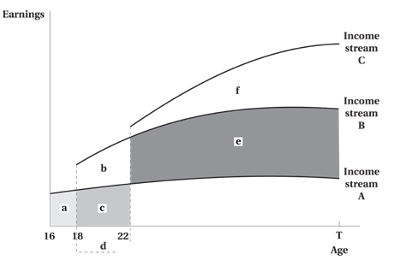

- The area labeled e) refers to:
                - The explicit, out-of-pocket costs incurred
                - The opportunity costs incurred by someone who opted for income stream B (a high school graduate)
                - The earnings premium earned by someone who opted for income stream B (a high school graduate) relative to a worker who did not obtain a high school diploma.
                - The earnings premium earned by someone who opted for income stream C (a university graduate) relative to a worker who graduated from high school.
                - The total cost of attending university

- The sum of the areas labeled b), c), and d) refers to:
                - The explicit, out-of-pocket costs incurred
                - The opportunity costs incurred by someone who opted for income stream B (a high school graduate)
                - The earnings premium earned by someone who opted for income stream B (a high school graduate) relative to a worker who did not obtain a high school diploma.
                - The earnings premium earned by someone who opted for income stream C (a university graduate) relative to a worker who graduated from high school.
                - The total cost of attending university

- Recent studies on economic assimilation for Canadian immigrants have found all of the following, with the exception that:
              - The entry effect is diminishing over time as the recent immigrants had higher levels of skills than the earlier immigrants.
              - The earnings return to a year of education is much lower for immigrants educated outside Canada.
              - The earnings return to years of experience is much lower for immigrants educated outside Canada.
              - "Age at immigration" matters.
              - The assimilation rates are uniformly too low for the average earnings of any cohort of immigrants to catch up with the comparable native born.

- Which of the following is the most common source region of immigrants to Canada?
              - Asia
              - The Middle East
              - Europe
              - North America (the US and Mexico)
              - Latin America

- Which of the following is not a criterion for the point system for immigration?
              - The level of education of the applicant
              - The applicant's proficiency in the official languages
              - The applicant's degree of work experience
              - The applicant's source country
              - An assessment of the applicant's adaptability to the Canadian labour market

- Which of the following is NOT a fact drawn from recent changes in patterns of immigration to Canada?
              - In 2019, India was the most important source country, accounting for 25 % of immigrants
              - The share of immigrants from the assessed classes is higher than it was two decades ago.
              - The variations in the sources of global conflict or economic crises do affect the changing pattern of immigration to Canada from source countries.
              - Europe is an important source of immigrants to Canada
              - While immigrant shares are highest in Toronto and Vancouver, they have grown in other large cities as well

- Based on the most recent studies, which of the following is NOT a factor that contributes to the difficulties for immigrants in finding a job?
              - poor knowledge of the Canadian labour market
              - a lack of job-related skills specific to Canada
              - weak English-language facility
              - Not having a university degree
              - A lack of Canadian working experience

- Which of the following is NOT a fact drawn from recent changes in patterns of immigration to Canada?
              - In 2019, India was the most important source country, accounting for 25 % of immigrants
              - The share of immigrants from the assessed classes is higher than it was two decades ago.
              - The variations in the sources of global conflict or economic crises do affect the changing pattern of immigration to Canada from source countries.
              - Europe is an important source of immigrants to Canada
              - While immigrant shares are highest in Toronto and Vancouver, they have grown in other large cities as well

- Regarding the point system revised in 2016, which of the following category is given the maximum score?
              - Education
              - Command of the official languages
              - Work experience
              - Age
              - Adaptability to the Canadian labour market

- Which of the following is NOT a fact drawn from recent studies regarding the impact of immigration on labour market?
              - Immigration has no significant effect on the wages of native-born workers.
              - Immigrants and natives with the same observed skill levels are not perfect substitutes.
              - Immigrants to the United States tend to be more skilled than those to Canada.
              - Sample size in Canadian census data may be a problem in the earlier empirical research.
              - All of the choices are correct.

- Based on the most recent studies, which of the following is NOT a factor that contributes to the difficulties for immigrants in finding a job?
              - poor knowledge of the Canadian labour market
              - a lack of job-related skills specific to Canada
              - weak English-language facility
              - Not having a university degree
              - A lack of Canadian working experience

- The demand theory of discrimination focuses on which of the following?
              - The demand for female labour is reduced relative to the demand for equally productive male labour.
              - The demand for female labour relies on the preferences of the recruitment and hiring committee of each firm.
              - Females tend to be less aggressive than males when they are negotiating wages with their employer.
              - Females are restricted from entering certain occupations, and are thus crowded into other occupations.
              - Women have a higher labour force participation rate than men.

- The supply theory of discrimination focuses on which of the following?
              - The supply of female labour is reduced relative to the demand of female labour.
              - The supply of female labour relies on the preferences of the hiring committee of each firm.
              - The supply of female labour to certain occupations or industries is increased as a result of discrimination.
              - Women have a higher labour force participation rate than men
              - Females receive lower salaries for the typical "male-type" jobs.

- The crowding hypothesis states that:
              - Females will not be hired when there is a lack of jobs.
              - Females will receive a lower salary in executive-level employment.
              - Females tend to receive the smallest offices, in case of congested office spaces.
              - Females tend to be segregated into "female-type" occupations.
              - Females receive lower salaries for the typical "male-type" jobs.

- When one breaks down the difference in earnings between men and women into the part due to productivity differences and the part due to discrimination, one produces the:
              - the male-female earnings gap
              - the total discriminatory impact
              - the Oaxaca decomposition
              - the market premium
              - the comparable worth amount

- Within the framework of the Oaxaca decomposition, the basic approach to analyzing whether there exists wage discrimination against women is to:
              - compare the actual mean wage of women to the actual mean wage of men.
              - compare the actual wage of women to the predicted wage that they would earn given female attributes and coefficients from the male equation.
              - compare the actual wage of women to the predicted wage that they would earn given male attributes and coefficients from the male equation.
              - compare the actual wage of women to the predicted wage that they would earn given female attributes and coefficients from the female equation.
              - search for anecdotal cases of low-paid women that appear to be affected by discrimination.

- Which element of the Oaxaca Decomposition reflects the wage discrimination?
              - The differences in the estimated coefficients between the male and the female wage equations
              - The differences in the attributes between men and women
              - The explained component of the wage differential
              - The differences in the predicted wages between men and women
              - None of the choices are correct.

- Consider the Oaxaca framework for the decomposition of the wage gap between two groups of workers. The variables that are included as controls that might explain the gap might involve all of the following with the exception of:
              - Ability and motivation on the job
              - Workplace characteristics
              - Education
              - Experience
              - Occupation

- Which of the following statements concerning gross flows and net flows is true?
              - Net flows take account of workers moving in both directions between labour market states
              - Gross flows are typically smaller in magnitude than net flows
              - In a steady state, gross flows are equal to zero
              - Only gross flows are relevant for determining the unemployment rate
              - If the net flow is zero, then the gross flow is zero

- An analysis of the incidence rates of unemployment and the average duration of unemployment across demographic groups reveals that:
              - those groups with the highest incidence tend to exhibit the shortest durations and vice-versa.
              - those groups with the highest incidence tend to exhibit the longest durations and vice-versa.
              - there is no apparent pattern.
              - the pattern of comparisons tend to change a lot over time.
              - data are not available in order to make these comparisons.

Questions 59-60.
The figure shows the age-earnings profiles for the native born and for immigrants. YSM = years since immigration

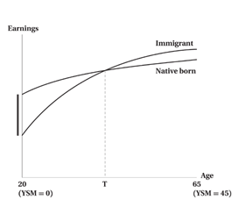
- The entry effect for a new cohort of immigrants is represented by:
                - The distance between the two profiles at age 65
                - The distance between the two profiles at the point labelled ‘T'
                - The distance between the two profiles at age 20
                - The slope of the immigrants' profile minus the slope of the native-born profile
                - The slope of the native-born profile minus the slope of the immigrants' profile

- The interpretation of the point labelled ‘T' is which of the following?
                - The returns to age
                - The wage discrimination effect
                - The point at which the earnings of natives catch up to the earnings of immigrant
                - The entry effect
                - The point at which assimilation has been reached.

Figure 12-2:
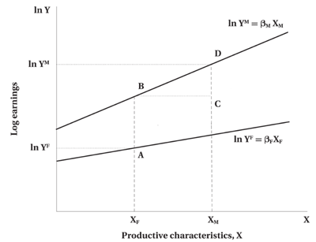

- Consider the Oaxaca framework for the decomposition of the wage gap between two groups of workers. In figure 12-2, the portion of the wage gap that might be attributed to discrimination is:
                - The distance between B and C
                - The distance between D and C
                - The distance between A and B
                - The distance between D and A
                - Indeterminant

- Consider the Oaxaca framework for the decomposition of the wage gap between two groups of workers. In figure 12-2, the portion of the wage gap that is attributed to pre-market characteristics is:
                - The distance between B and C
                - The distance between D and C
                - The distance between A and B
                - The distance between D and A
                - Indeterminant

The following data were drawn from the Labour Force Survey for February 2021:
Working-age-population: 31.2 million
Labour force: 20.2 million
Employment: 18.5 million

- In reference to the above Labour Force Survey, what was the unemployment rate?
                - 8.2 %
                - 91.5 %
                - 64.7 %
                - 59.4 %
                - Indeterminant

- In reference to the above Labour Force Survey, what was the labour force participation rate?
                - 8.2 %
                - 91.5 %
                - 64.7 %
                - 59.4 %
                - Indeterminant

- In reference to the above Labour Force Survey, what was the employment rate?
                - 8.2 %
                - 91.5 %
                - 64.7 %
                - 59.4 %
                - Indeterminant

